**This is how I’m do the project.**

**Firstly, am tested the Dust sensor, connect form the sensor the Pin 1 to the VCC, Pin 3 to the GND, pin9 to the pin14 on the ESP32.**

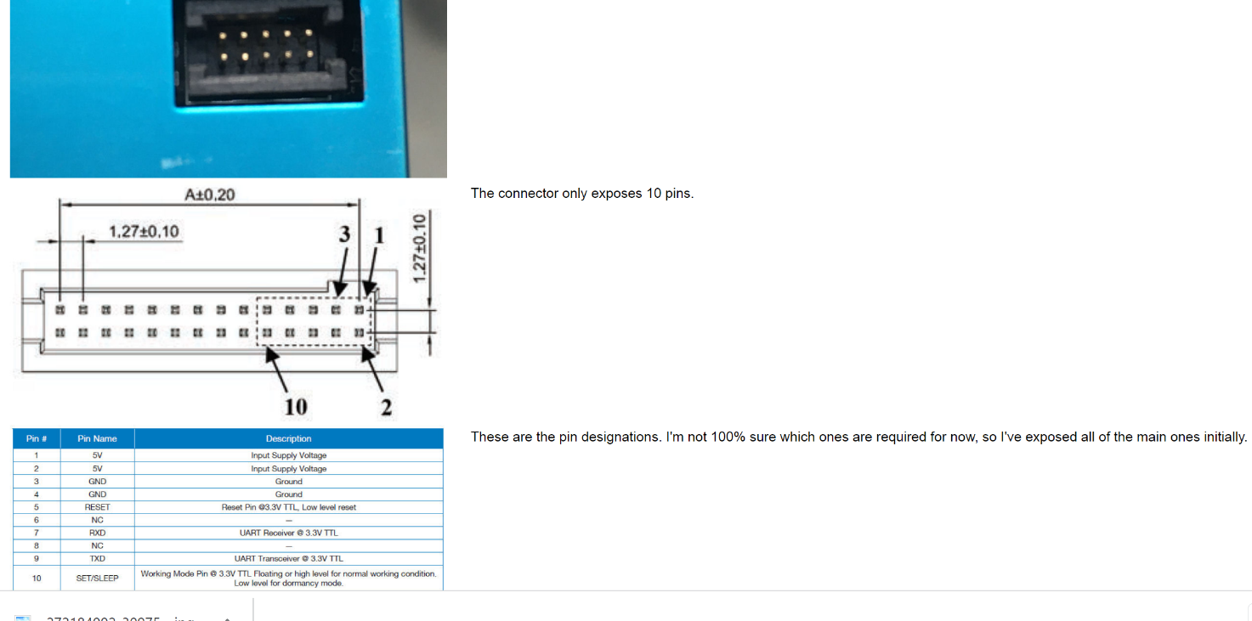

**I’m use this C cod for Dust sensor.**

#include <Wire.h>

#define dust_sensor 12

void setup() {

// put your setup code here, to run once:

Serial.begin(115200);

Serial2.begin(9600,SERIAL_8N1,dust_sensor,-1);

}

void loop() {

// put your main code here, to run repeatedly:

byte dust_byte[30];

int dust_index = 0;

int dust_data[3];

int l = 0;

while(!Serial2.available()) {

}

if(Serial2.read() == 0x42 && Serial2.read() == 0x4D) {

//Serial.println("header done");

for(int i = 0; i < 14; i++) {

if(Serial2.available()) {

//if(i%2 == 0) {

//Serial.print("HIGH ");

//} else {

//Serial.print("LOW ");

//}

dust_byte[dust_index] = Serial2.read();

//Serial.println(dust_byte[dust_index]);

dust_index++;

}

}

for(int i = 14; i < 30; i++) { //flush the no-data bytes[

if(Serial2.available()) {

Serial2.read();

}

}

}

//int h_length = dust_byte[0];

//int l_length = dust_byte[1];

//l = h_length + l_length + 2;

//Serial.print("length: ");

//Serial.println(l);

for(int i = 0; i < 3; i++) {

int value = (dust_byte[2+i*2]<<4) + dust_byte[2+1+(i*2)];

dust_data[i] = value;

}

Serial.print("PM1:");

Serial.print(dust_data[0]);

Serial.print(",\t");

Serial.print("PM2.5:");

Serial.print(dust_data[1]);

Serial.print(",\t");

Serial.print("PM10:");

Serial.print(dust_data[2]);

Serial.println("");

}

**Secondly, I’m started to connect the Gps+ antenna to the ESP32. From pins VCC to VCC, from TX to Pin15, from RX to Pin2, from GND to the GND.**

**I’m add the parameters to the GPS sensor C cod some**

#include <TinyGPS++.h>

#include <SoftwareSerial.h>

static const int RXPin = 15, TXPin = 2;

static const uint32_t GPSBaud = 9600;

TinyGPSPlus gps;

SoftwareSerial ss(RXPin, TXPin);

void setup()

{

Serial.begin(9600);

ss.begin(GPSBaud);

Serial.println(F("NEO-6M GPS MODULE QUICK TEST"));

Serial.print(F("Testing with TinyGPS++ library v. ")); Serial.println(TinyGPSPlus::libraryVersion());

Serial.println();

}

void loop()

{

while (ss.available() > 0)

if (gps.encode(ss.read()))

displayInfo();

if (millis() > 5000 && gps.charsProcessed() < 10)

{

Serial.println(F("No GPS Module Found! Check Hardware!!"));

while(true);

}

}

void displayInfo()

{

Serial.print(F("Location: "));

if (gps.location.isValid())

{

Serial.print(gps.location.lat(), 6);

Serial.print(F(","));

Serial.print(gps.location.lng(), 6);

}

else

{

Serial.print(F("INVALID"));

}

Serial.print(F(" Date/Time: "));

if (gps.date.isValid())

{

Serial.print(gps.date.month());

Serial.print(F("/"));

Serial.print(gps.date.day());

Serial.print(F("/"));

Serial.print(gps.date.year());

}

else

{

Serial.print(F("INVALID"));

}

Serial.print(F(" "));

if (gps.time.isValid())

{

if (gps.time.hour() < 10) Serial.print(F("0"));

Serial.print(gps.time.hour());

Serial.print(F(":"));

if (gps.time.minute() < 10) Serial.print(F("0"));

Serial.print(gps.time.minute());

Serial.print(F(":"));

if (gps.time.second() < 10) Serial.print(F("0"));

Serial.print(gps.time.second());

Serial.print(F("."));

if (gps.time.centisecond() < 10) Serial.print(F("0"));

Serial.print(gps.time.centisecond());

}

else

{

Serial.print(F("INVALID"));

}

Serial.println();

}

**Temperature sensor LM35, connect from sensor to esp32, 1 been to 3.3v, 2 middle been to PIN 12 and LED to PIN 13, right been to the GND.**

Code C is:

const float hot = 25; //hot parameter

const float cold = 15; //cold parameter

int count =10;// dont caunt first 10 mesurements

void setup() {

pinMode(12, INPUT );

pinMode(13, OUTPUT);

// Begin serial communication at 9600 baud rate

Serial.begin(9600);

}

void loop() {

float sensor = analogRead(14);

float temp = (sensor / 4095.0)* 3.3;

// Convert the voltage into the temperature in Celsius

float temperatureC = temp * 100;

if (temperatureC < cold && count == 0){

digitalWrite(13, LOW);

}

else if (temperatureC >= hot && count == 0){

digitalWrite(13, HIGH);

} else {

count--;

}

delay(1000);

// подключаем термометр и лампу

// Print the temperature in Celsius

Serial.print("Temperature: ");

Serial.print(temperatureC);

Serial.print("\xC2\xB0"); // shows degree symbol

Serial.print("C | ");

// Print the temperature in Fahrenheit

float temperatureF = (temperatureC * 9.0 / 5.0) + 32.0;

Serial.print(temperatureF);

Serial.print("\xC2\xB0"); // shows degree symbol

Serial.println("F");

delay(1000); // wait a second between readings

}

// подключаем термометр и лампу

**Then im connect AIR sensor from D to Pin32, from C to Pin32, -(minus) to GND, +(plus) to 5 volt.**

//may be wrong...

//wire library

#include <Wire.h>

//air quality sensor library

#include <DFRobot_SGP40.h>

//the new pins

int const I2C_SDA = 33;

int const I2C_SCL = 32;

TwoWire I2CBME = TwoWire(0);

DFRobot_SGP40 air_sensor;

void setup(){

Serial.begin(115200);

I2CBME.begin(I2C_SCL, I2C_SDA);//last param is clock freq

air_sensor.begin(10000);

}

void loop() {

// put your main code here, to run repeatedly:

uint16_t index = air_sensor.getVoclndex();

Serial.print("vocIndex = ");

Serial.println(index);

delay(1000);

}